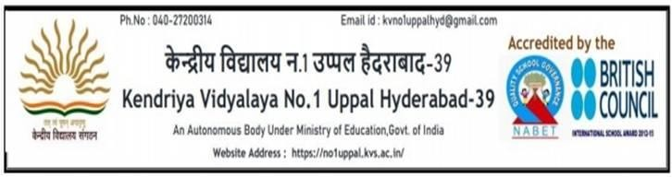
Registration No.

REGISTRATION FORM FOR CLASS-XI FOR THE ACADEMIC SESSION 2023-24
KV 1U
KV1U
(For students of KV-1,Uppal) (Science / Commerce)
Name of the student (in BLOCK letters) |  |  |  |  |  |  |  |  |  |  |  |  |  |  |  | PHOTO
Class – X / Section |  |  | KV-1 Uppal  Admission No. |  |  | 0
UBI unique ID
Date of Birth |  |  |  |  | Gender: |  |  |  |  | M / F
Email ID of the Parent
Mobile Number:  Put a tick mark for  communication use | Father
 | Mother

Particulars of Parents:

 | MOTHER | FATHER
NAME
OCCUPATION
DEPARTMENT/OFFICE/PRIVATE/SELF
EMPLOYED
Service Category⁺⁺
⁺⁺SERVICE Cat-1: Central/Defence/Ex-Ser, Cat-2: Central PSU/ Autonomous / KVS, Cat-3: State Govt., Cat-4: State PSU/ Autonomus, Cat-5: All Others/Private/Business.

Caste/ Religion/GENDER Particulars: (Attach photocopy of certificate)

CATEGORY ( SC/ ST / OBC-NCL / GEN)
Are you a SINGLE GIRL CHILD ? | Yes / No

Result of Class X (Attach photocopy of Marks sheet)

Subject | Marks Obtained | Subject | Marks Obtained
English |  | Science
Hindi |  | Social Science
Sanskrit |  | Total Marks | /500
Maths (Stand/ Basic) |  | Percentage (%)

Marks in Science & Maths CBSE Roll No :

Year of Passing Class- X:

OTHER ACHIEVEMENTS (CO-SCHOLASTIC): YES / NO
(If YES, Any one that gives you highest concession may be ticked. Attach Photo copy of the certificate)
 | SPORTS & GAMES | NCC | SCOUT & GUIDE | ADVENTURE | CONCESSION ALLOWED | Put a tick mark against the  achievement
A | Participation at SGFI | A-Certificate & Participation in  Republic/PM rally | Rashtrapathi Puraskar award  certificate | - | 6%
B | Participation at KVS Nationals/  State Level | A-Certificate & best cadet in  Distt/State level | Rajyapuraskar award certificate  with 7 Badges | - | 4%
C | Participation at KVS Regional/  State Level | A-Certificate | Tritiya sopan certificate with 5  Badges | 10 days adventure activity | 2%

SUBJECT COMBINATION OFFERED: (Choose and Tick the desired stream with subject combination)

Science Stream :  - English, Hindi, Physics, Chemistry, Biology  - English, IP, Physics, Chemistry, Biology  - English, Math, Physics, Chemistry, Biology  - English, Math, Physics, Chemistry, Computer Science | Commerce Stream:  - English, Hindi, Accountancy,  Business Studies, Economics  - English, Math, Accountancy,  Business Studies, , Economics  - English, Accountancy, Business Studies, Economics, I.P
DECLARATION BY THE STUDENT:
My option of different streams ( Viz, SCIENCE,COMMERCE), if eligible and vacant
Priority 1:
Priority 2:
(write Science or Commerce)
Date: / /2023
Signature of the student
DECLARATION BY THE PARENT:

I, parent of hereby declare that the details provided by me are correct to the best of my knowledge and belief. I understand that mere application does not confer to admission into Kendriya Vidyalaya. I understand that the admissions are carried out as per the KVS Admission Guidelines-2022-23. We abide by the rules of KVS. In case of any discrepancy this application may summarily be rejected.
Date:
/ /2023
Signature of the parent

Allotted/ Rejected Section GROUP Admission Committee

PRINCIPAL

